Name-Veman chandrashekharaddi Ritti
Usn-1BM24CS322
Batch-k(2)
INSURANCE DATABASE
Code=
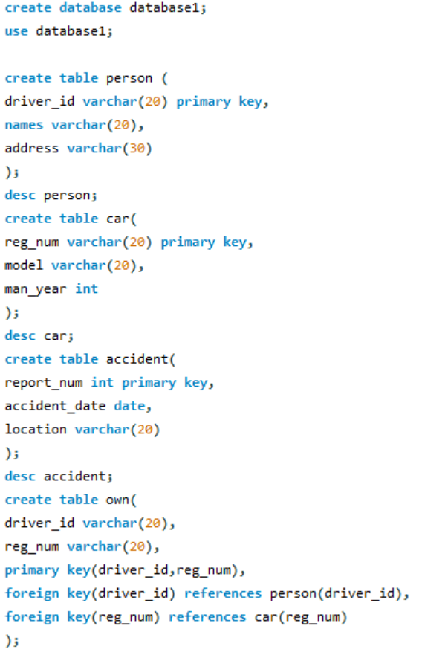
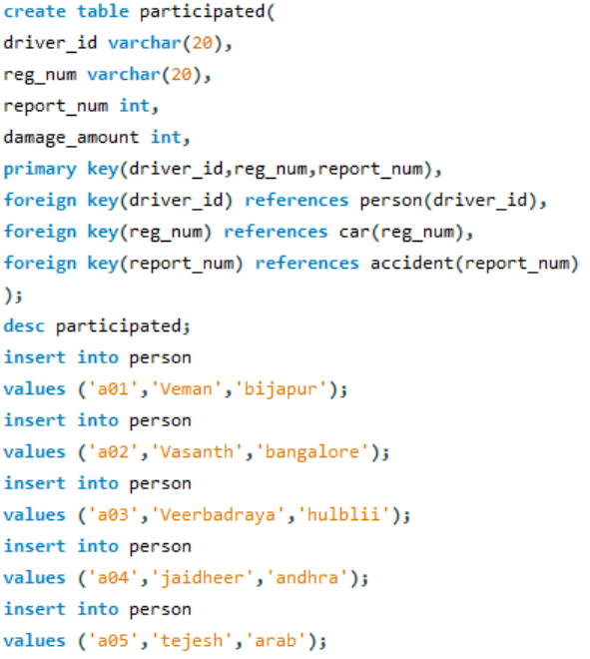
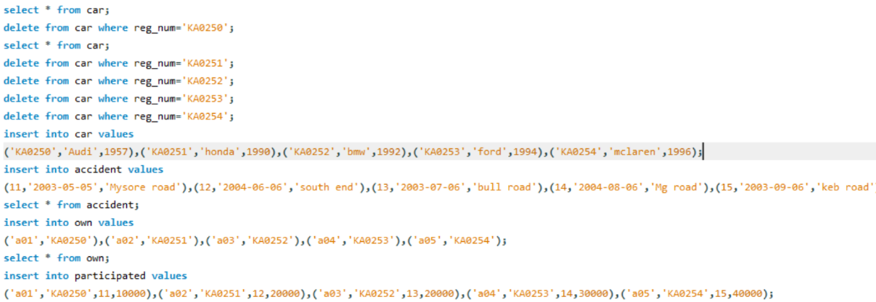
1)Show all accidents
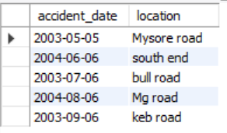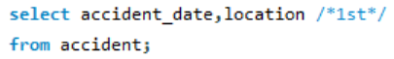

2)find drivers who caused damage more than 25000
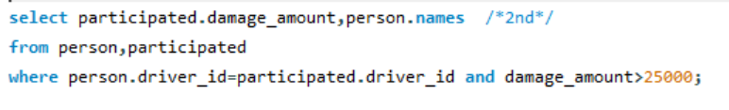
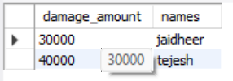
3)list each driver with the cars they own
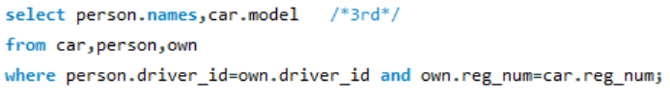
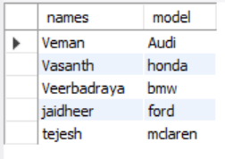
4)Show accidents and drivers involved including damage
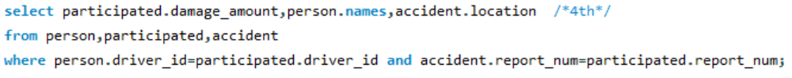
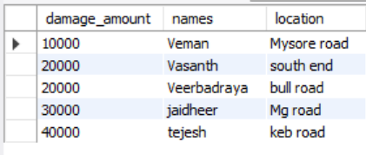
5)total damage per accident report
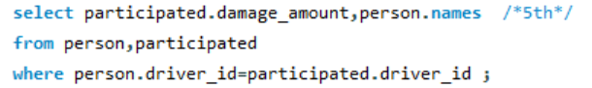
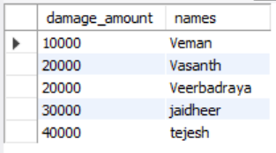
6)Drivers who were involved with more than one accident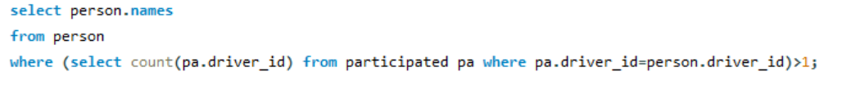

7)Cars that never had any accident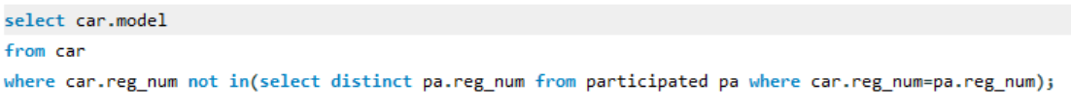

8)show the latest accident
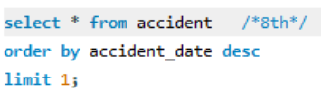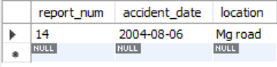

9)Average damage ammount per driver
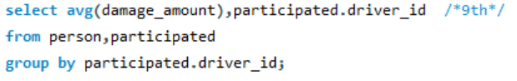
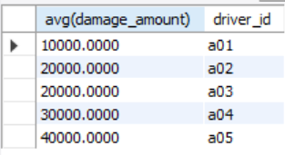

10)Update any damage amount to 25000 corresponding to a driver id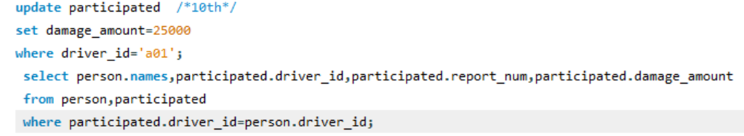
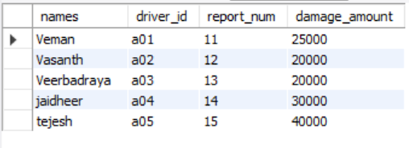

11)Find the driver who caused the maximum damage
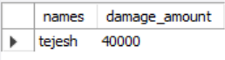

12)Show car model involved in accident with total damage >20000
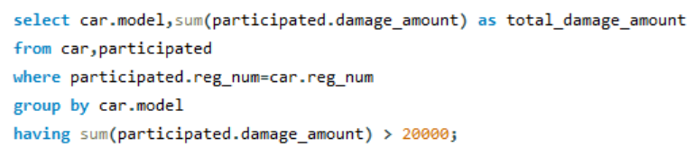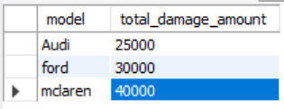

13)Create a view summarizing accidents with participants count and total damage
